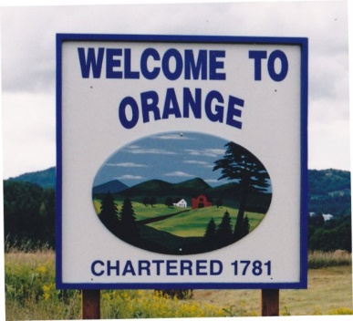
Town of Orange
Grant Committee Meeting
November 9, 2023, 5:00pm
Orange Town Complex

1. Call to Order
2. Agenda Revisions
3. Discuss Current Grant Applications
- MERP
- MPG
- Emissions
4. Discuss Current Grants in Progress
- Park and Ride
- Better Back Roads
5. Discuss Potential Grants
6. Other Business
7. Adjourn

