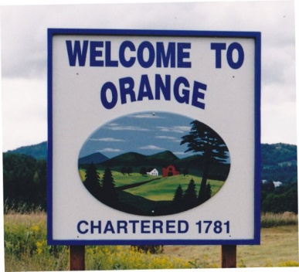
Town of Orange
Grant Committee Meeting
September 7, 2023, 4:30pm
Orange Town Complex

- Call meeting to order
- Agenda revisions
- Confirm Rules of Procedures and Committee Positions
- Set meeting schedule
- Review Grant Database
- Review time-sensitive grants
- Adjourn

