TOWN OF ORANGE ABATEMENT NOTICE

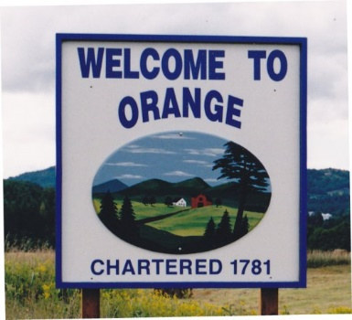

Town of Orange
Board of Abatement Hearing

The Board of Abatement for the Town of Orange will be meeting on the following dates and times in the Orange Town Hall. There will be an organizational meeting of the Board of Abatement and the Abatement Hearings will being at 6:30pm

September 7, 2022 | Hearing Requested By: Mr. John McNeil, Lister
6:00pm | Audet/Hedges, Hallock/Renfrew, Choge, Golden, Lamell, Morrison, Wheeler and Welch/Farnham
You may request more information regarding the status of each abatement hearing by contacting the Town Clerk at (802) 479-2673 or by email at townclerk@orangevt.org. The minutes of the abatement hearing will be posted at the Town of Orange Town Clerk’s office and online at orangevt.org within 5 days of the hearing.

