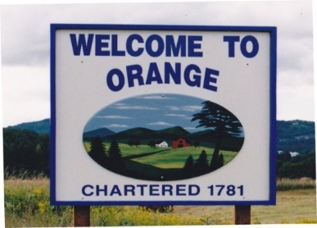
TOWN OF ORANGE
BOARD OF CIVIL AUTHORITY MINUTES
November 3, 2021 at 6:00pm

BCA Members Present:
Fred Kidder, Sue Perreault, Lee Martenson, Angela Eastman, Tina Otis and Lee Youngman

Call Meeting to order
Mr. Kidder called the meeting to order at 6:13pm.

Pledge of Allegiance:
Mr. Kidder led the BCA in the Pledge of Allegiance.

New Business
- Discuss obtaining a tabulator from the State of Vermont and vote on use of Tabulator
Discussion was had regarding obtaining a Tabulator from the State of Vermont amongst the members of the board. Mr. Martenson made a motion to request a Tabulator from the State of Vermont. This was seconded by Ms. Perreault. The motion passed unanimously. Discussion was had regarding when to use the Tabulator at which elections. Ms. Youngman made a motion to use the Tabulator at all elections except at Town Meeting floor votes. This was seconded by Ms. Otis. The motion passed unanimously.

- Discussion regarding reapportioning the VT General Assembly, Senate and the House
Discussion was had regarding the upcoming reapportioning amongst the members of the board. Ms. Youngman made a motion to accept the reapportioning as written. This was seconded by Ms. Otis. The motion passed unanimously. Ms. Youngman will write a letter to the State of Vermont.
Other Business:
No other business noted
Adjournment:
Mr. Kidder made a motion seconded by Ms. Youngman to adjourn the meeting at 6:30 p.m. All in favor. The motion passed unanimously.

Attest:

Angela Eastman
Town Clerk

