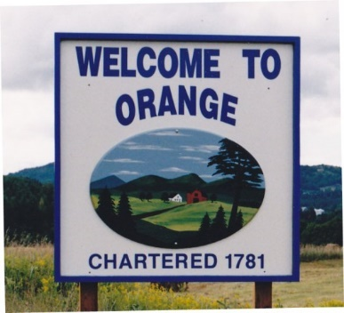
TOWN OF ORANGE
392 US ROUTE 302, ORANGE, VT 05641
802-479-2673
www.orangevt.org

NOTICE OF BOARD OF CIVIL AUTHORITY HEARING

October 25, 2021
Pursuant to the provisions of 17 V.S.A §2451, notice is hereby given that the Town of Orange Board of Civil Authority will convene on the date listed below to discuss obtaining a tabulator from the State of VT and vote for use of tabulator and discussion of reapportioning the VT General Assembly, Senate and the House. This happens every 10 years in Vermont. Please join us, as BCA feedback needs to be presented by November 15th. Please read the enclosed memo from Thomas A. Little, Chair, Legislative Apportionment Board and be prepared to discuss this at the upcoming meeting.

November 3, 2021 6:00 p.m. Orange Town Hall

Sincerely,

Angela J. Eastman
Town Clerk

