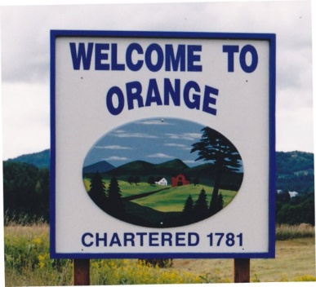
TOWN OF ORANGE
BOARD OF CIVIL AUTHORITY MINUTES
September 7, 2021

BCA Members Present:
Fred Kidder, Sue Perreault, Lee Martenson, Angela Eastman, Art McNeil and John McNeil

Others Present:
Jeff and Jill Tremblay, Frank and Siobhan Perricone and Samantha and Shane Lefebvre.

Call Meeting to order and Pledge of Allegiance:
Ms. Eastman called the meeting to order at 5:33pm and pledge was led at the last meeting.

Biennial VT Voter Checklist Purge
The BCA reviewed the voter checklist and discussed the voters that need to be challenged. The BCA authorized the Town Clerk to challenge the voters as discussed. This completed the biennial purge.
Discussion regarding deactivating Trickle Brook Drive parcel
Discussion was had to deactivate Trickle Brook Drive. Both the BCA and the residents had separate time for input. The residents of Trickle Brook Drive will go in front of the Selectboard to discuss whether or not to have the town take over the road. Ms. Youngman made a motion to discontinue the road as a parcel. This was seconded by Ms. Eastman. The motion passed unanimously.

Other Business:
No other business noted
Adjournment:
Ms. Youngman made a motion seconded by Mr. Kidder to adjourn the meeting at 5:56 p.m.

Attest:

Angela Eastman
Town Clerk

